**Project Design Phase-II**

**Technology Stack (Architecture & Stack)**

|  |  |
| --- | --- |
| Date | 28 October 2022 |
| Team ID | PNT2022TMID43155 |
| Project Name | Project – Plasma Donor Application |
| Maximum Marks | 4 Marks |

**Technical Architecture:**

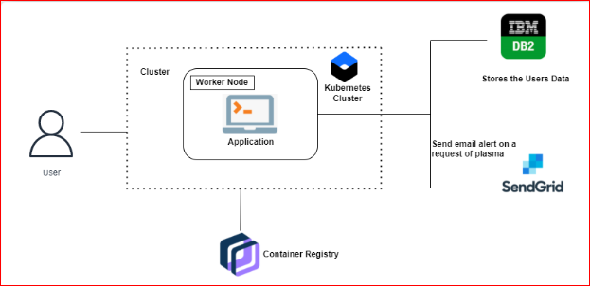

**Table-1 : Components & Technologies:**

|  |  |  |  |
| --- | --- | --- | --- |
| **S.No** | **Component** | **Description** | **Technology** |
|  | User Interface | The interaction between the user and application e.g., Web UI, Mobile App, Chatbot etc. | HTML, CSS, JavaScript / Bootstrap etc. |
|  | Application Logic-1 | Framework used for design the application | Python, Python - Flask |
|  | Application Logic-2 | Accessing the cloud and storing the details of the users both donors and patients. | IBM Cloud, IBM DB2 |
|  | Application Logic-3 | Docker is an open-source platform for building, deploying, and managing containerized applications. | Docker |
|  | Database | Data Type, Configurations etc. | SQL. |
|  | Cloud Database | Database Service on Cloud | IBM DB2, IBM Cloudant etc. |
|  | File Storage | File storage requirements | IBM Block Storage or Other Storage Service or Local Filesystem |
|  | External API-1 | They make it easier for developers to store, manage and deploy container images. | Container Registry |
|  | External API-2 | Application Deployment on Local System / Cloud | Local, Cloud Foundry, Kubernetes, etc. |

**Table-2: Application Characteristics:**

| **S.No** | **Characteristics** | **Description** | **Technology** |
| --- | --- | --- | --- |
|  | Open-Source Frameworks | Python – flask is an open-source framework used to develop the application | Python - Flask |
|  | Security Implementations | Container registry and Kubernetes Cluster are used for encryption of data. | Container registry and Kubernetes Cluster |
|  | Scalable Architecture | Kubernetes Cluster allow containers to run across multiple machines and environments. | Kubernetes Cluster |
|  | Availability | Kubernetes Cluster provides all time availability. | Kubernetes Cluster |
|  | Performance | Docker improves the application performance. | Docker |